TIBCO TEA 2.1 Silent Mode Installation

**Hardware Requirements:**

* A minimum of 512 MB physical memory is required.

**Software Requirements:**

* Install Java 1.7.x (Required).
* Web Browser (Required) to run TIBCO Enterprise Administrator Server UI.
* Install TIBCO 5.1.1 (optional).
* Install Python 2.7 or later version (optional).

**Installing in Silent Mode:**

* By default the installer uses the TIBCOUniversalInstaller_tea_<Version>.silent file

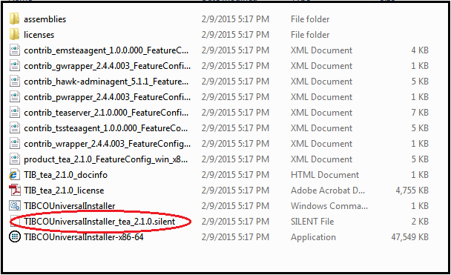

* Make a copy of this file and rename the file. Eg. Newfile.silent
* By the help of text editor( eg. Notepad), edit the installation location and features to install.

1. <entry key="installationRoot">C:\Program Files\tibco\tea </entry>

The above location is installation location. Change the location if required.

1. <entry key="environmentName"> tea-2.1</entry>

* For an existing environment, the installationRoot and environmentName must match with the pre-existing environment.
* For an non existing environment, the installationRoot and environmentName must be unique and does not match with the pre-existing environment.

1. <entry key="configDirectoryRoot">C:\programData\tibco</entry>

Specify the location of configuration file.

1. <entry key="useInstallProfile">true</entry>

For single profile:

<entry key="selectedProfiles">1) TIBCO Enterprise Administrator</entry>

For both profile:

<entry key="selectedProfiles">1) TIBCO Enterprise Administrator,2) TIBCO HAWK Agent</entry>

The 'selectedProfiles' value is a comma separated list of profiles to install. If a profile is listed which does not exist, then it is ignored. At least one profile must be listed if useInstallProfile is set to true.

1. <entry key="java.home.directory">c:\Program Files\Java\jdk1.7.0_71</entry>

Location of Java.

* Now Open the cmd (Console window), and navigate to the temporary directory where Tea_Admin_2.1 has been extracted.
* Run the silent installer by below command:

TIBCOUniversalInstaller.cmd –silent [-V responseFile=”newFile.silent” ]

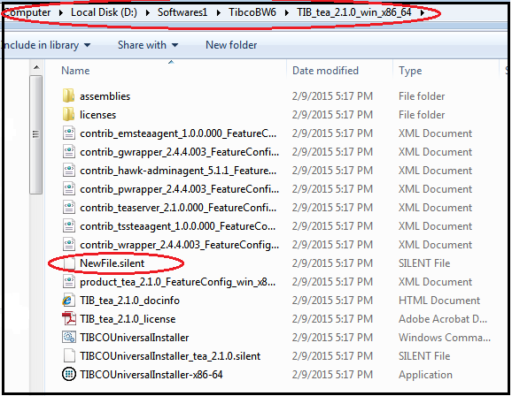

**Configuring the TIBCO Enterprise Administrator Server:**

* To customize the configuration for admin go to config file. Default location of config file is <TIBCO_CONFIG_HOME>\tibco\cfgmgmt\tea\conf.

The following properties can be modified in the config file.

